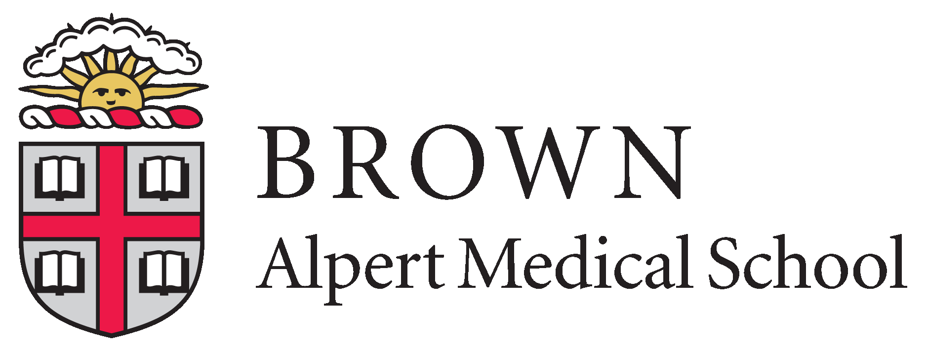

BROWN PSYCHIATRY SUMMER RESEARCH FELLOWSHIP

Description
Two summer research fellowships are available for medical students from under-represented groups to engage in intensive 8-week summer projects under the mentorship of a Brown Department of Psychiatry and Human Behavior faculty member. Additional career mentorship will be provided by Audrey Tyrka, MD, PhD, Director of Research Training, Tracey Guthrie, MD, Director of the Brown psychiatry residency program, and Steven Rasmussen, MD, Chair of the Department of Psychiatry and Human Behavior. Each fellow will work on one of the following areas.

Prediction of Suicidal Thoughts and Behaviors
Mentors: Michael Armey, PhD and Heather Schatten, PhD
Opportunities for students working in this laboratory involve the prospective prediction of suicidal thoughts and behaviors in psychiatric inpatients at high risk for suicide using multiple novel methods including: genetics, psychophysiology (i.e., ECG, EDA, EMG, EEG), implicit cognitive markers involved in attention, interpretation, and memory processes, eye tracking, machine learning algorithms associated with underlying features of speech, ecological momentary assessment (EMA), and fMRI. Students may also gain experience with the development of a smartphone app for suicide prevention.

Neurobiological Effects of Childhood Trauma
Mentor: Audrey Tyrka, MD, PhD
This laboratory focuses on the neurobiological effects of early trauma that put children at risk for the
development of psychiatric conditions and associated health problems. Studies of adults and children provide measures including blood, saliva and hair-based markers of stress, inflammation and metabolism, psychiatric and stressor interviews, cognitive testing, EEG, and measures of metabolism and cellular aging in adults and children with a history of early stress and trauma.

Neurocircuitry-Based Interventions for Obsessive Compulsive Disorder (OCD)
Mentor: Nicole McLaughlin, PhD
Work in this laboratory focuses on neurocircuitry-based interventions for OCD, including invasive (ablative procedures, deep brain stimulation) and non-invasive (transcranial direct current stimulation, transcranial magnetic stimulation) techniques. There is a particular focus on understanding clinical, cognitive, neuroimaging predictors of clinical outcome related to the use of these techniques, using both qualitative and quantitative methods.

Health Risk Behaviors Among Individuals with Psychiatric and Substance Use Disorders
Mentor: Ana Abrantes, PhD
The summer student will have the opportunity to work on one or more projects related to modifiable health risk behaviors (e.g., physical activity, dietary intake, cigarette smoking) among individuals with psychiatric disorders (e.g., depression) and/or substance use disorders (i.e., alcohol and opioids). Current projects in the lab include technology-supported approaches such as fitness sensors and smartphone apps as well as device-based interventions (e.g., transcranial direct current stimulation) with both community and patient populations.
BROWN PSYCHIATRY SUMMER RESEARCH FELLOWSHIP
In anticipation of COVID-19-related restrictions on traveling and gathering being partially or fully lifted in time for the 8-week summer program, we are planning for in-person activities. However, should restrictions remain in place at the time of the summer program, we are well-equipped to provide a rich and meaningful remote summer research experience.

Purpose
Provide an opportunity for US medical students from diverse backgrounds to become familiar with academic research in psychiatry.

Eligibility
Medical students currently enrolled in US AAMC-accredited programs who are citizens or non-citizen nationals or permanent residents.

In spite of tremendous advancements in scientific research, information, educational and research opportunities are not equally available to all. NIMH encourages institutions to develop creative strategies to further diversify their student, post-doctorate and faculty populations to enhance the participation of individuals from groups identified as underrepresented in the biomedical, clinical, behavioral and social sciences. NIH encourages institutions to diversify their student and faculty populations to enhance the participation of individuals from groups that are underrepresented in the biomedical, clinical, behavioral and social sciences. The following racial and ethnic groups have been shown to be underrepresented in biomedical research: Blacks or African Americans, Hispanics or Latinos, American Indians or Alaska Natives, Native Hawaiians and other Pacific Islanders. In addition, it is recognized that underrepresentation can vary from setting to setting; individuals from racial or ethnic groups that can be demonstrated to be underrepresented can be considered.

Stipend
Students who are awarded the fellowship will receive $4,618 to support their living expenses. Students may also be eligible for up to $700 in travel expenses to travel to/from Providence, Rhode Island, and monthly bus passes for local transportation.

Application Materials:
- Complete the online application form by scanning the QR code below.
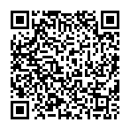
You can also access the survey by entering the code MR3LYM3C8 at https://redcap.lifespan.org/redcap/surveys/

- Send the following materials electronically as email attachments to mhutchinson@butler.org:
- Curriculum vitae or resume
- Personal statement about your experience and interest in psychiatry and research. Include personal career goals for you as they relate to this summer fellowship. Up to one page in length.
- One letter of recommendation from a faculty member.
- Letter from your dean’s office indicating you are in good standing in your program.

Progress Reports and Presentations
Students receiving summer funding through this application must present their summer work in poster format at the Brown Summer Showcase in Fall 2022 for local students, or in the Brown mentor’s laboratory for students from other institutions.

All application materials must be submitted electronically no later than March 7, 2022. Decisions will be made by April 4, 2022.

